SAVEETHA SCHOOL OF ENGINEERING

NAME : SHAIK MOHAMMAD

FAZLU

Reg.no :192211262

COURSE : SOFTWARE

ENGINEERING FOR

INDUSTIRAL

APPLICATION.

COURSE code : CSA1024

FACULTY : DR ARUL RAJ

DEPARTMENT : COMPUTER SCIENCE

ENGINEERING

YEAR : 1ST

Index

|  |  |
| --- | --- |
| S.NO. | EXPERIMENT NAME |
| 1 | USE-CASE diagram for Online Voting System using CASE tools. |
| 2 | USE-CASE diagram for Library Management System using CASE tools. |
| 3 | Draw and validate the flowchart to compute the quotient and remainder. |
| 4 | USE-CASE diagram for Online Shopping system using CASE tools. |
| 5 | USE-CASE diagram for Online Railway Reservation System using CASE tools. |
| 6 | USE-CASE diagram for Hospital Management System using CASE tools. |
| 7 | USE-CASE diagram for ATM system using CASE tools. |
| 8 | USE-CASE diagram for Online college management system using CASE tools. |
| 9 | USE-CASE diagram for Online Airline Reservation system using CASE tools. |
| 10 | Class diagram for online Airline Reservation system using CASE tools. |
| 11 | Class diagram for Online Voting System using CASE tools. |
| 12 | Class diagram for Library management System using CASE tools. |
| 13 | Class diagram for Online shopping System using CASE tools. |
| 14 | Class diagram for Online Railway reservation System using CASE tools. |
| 15 | Activity diagram for online Voting system using CASE tools. |
| 16 | Activity diagram for Library management system using CASE tools. |
| 17 | Activity diagram for Online shopping system using CASE tools. |
| 18 | Activity diagram for Online Railway reservation system using CASE tools. |
| 19 | Activity diagram for Hospital management system using CASE tools. |
| 20 | Using Raptor drawing the flowchart to check whether the given number is a palindrome or not. |
| 21 | Using Raptor drawing the flowchart to calculate Fibonacci series. |
| 22 | Using Raptor drawing the flowchart to swap two characters. |
| 23 | Using Raptor drawing the flowchart to display the length of the string. |
| 24 | Using Raptor drawing the flowchart to find whether the given number is prime or not. |
| 25 | Find Cyclomatic Complexity for a graph having number of edges as 12, number of nodes as 13 and number of predicate nodes in the flow graph as 5. |

Experiment-1

Aim: USE-CASE diagram for Online Voting System using CASE tools.

OBJECTIVE:

As an alternative for is easy voting system, where rigging of votes, insecurity etc. are usual which can be eliminated. At the same time, this new voting system is electoral voting System is easy to use, both for the official and people concerned. This type of voting system can completely eradicate all kinds of fraudulent activities especially casting votes from Same id more than once We are implementing the electronic voting system with the help of python.

Procedure:

* For drawing a use case diagram for online voting system, we have to download umbrella software for PC.
* After downloading the software install it in your PC and open it.
* Now just above the top of the work space an icon is there which contains several types of diagrams from that select use case.
* Your required tools displayed on top left of the screen (select, note, Anchor, Label, Box, Actor, use case, association, Directional association, Dependency, implements.)
* For drawing use case diagram for online voting system search a suitable diagram from google for reference. Now go to umbrella software select Actor and place it on the work space and name it as Administrator. For this use case diagram, we need another two actors and name it as Voter and Database.
* Now select the use case from tools and name them as Registration, issue of smart card, Login, Polling, Update and Result (related to the topic).
* Last step is to draw lines from particular Actors to their related activities.
* After drawing the use case diagram save it and take a screen shot of the diagram.
* Go to paint app in your PC and paste the image you captured and select only the image, copy it.
* Now open word document and paste it under related experiment.

OUTPUT:

USE CASE DIAGRAM FOR ONLINE VOTING SYSTEM

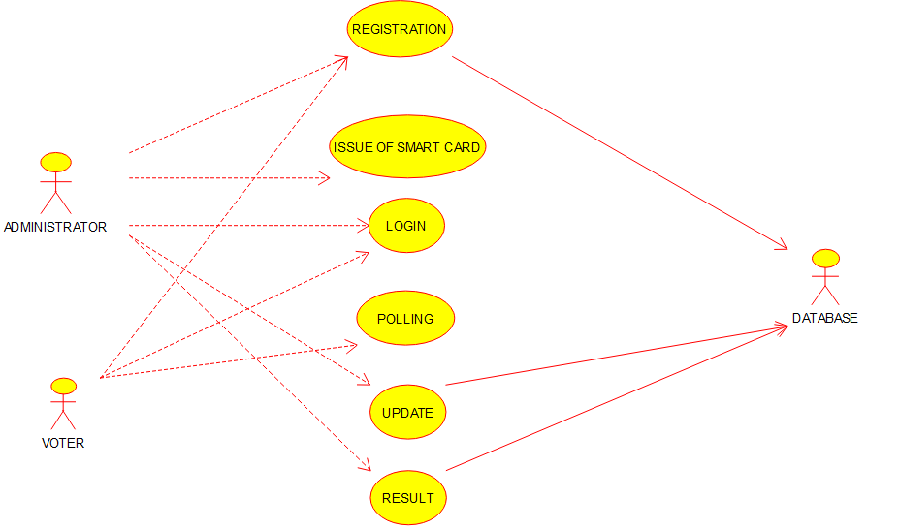

RESULT:

Thus, use case diagram for online voting system is implemented successfully.

EXPERIMENT-2

AIM: USE-CASE diagram for Library Management System using CASE tools.

OBJECTIVE:

With the advancement of technology, it is imperative to exalt all the systems into a user-friendly manner. The Library Management system (LMS) acts as a tool to transform traditional libraries into digital libraries. In traditional libraries, the students/user has to search for books which are hassle process and there is no proper maintenance of database about issues/fines. The overall progress of work is slow and it is impossible to generate a fast report. The librarians have to work allotted for arranging, sorting books in the book sells. At the same time, they have to check and monitor the lend/borrow book details with its fine. It is a tedious process to work simultaneously in different sectors.

PROCEDURE:

* For drawing a use case diagram for Library management system, we have to download umbrella software for PC.
* After downloading the software install it in your PC and open it.
* Now just above the top of the work space an icon is there which contains several types of diagrams from that select use case.
* Your required tools displayed on top left of the screen (select, note, Anchor, Label, Box, Actor, use case, association, Directional association, Dependency, implements.)
* For drawing use case diagram for Library management system search a suitable diagram from google for reference. Now go to umbrella software select Actor and place it on the work space and name it as Librarian. For this use case diagram, we need another actor and name it as Student.
* Now select the use case from tools and name them as Add publication, Add Book, Add Branch, Add Student, Search Book, Issue Book, Return Book, Penalty, Issue/Return Book report, Penalty report. (Related to the topic).
* Last 5 step is to draw lines from particular Actors to their related activities.
* After drawing the use case diagram save it and take a screen shot of the diagram.
* Go to paint app in your PC and paste the image you captured and select only the image, copy it.
* Now open word document and paste it under related experiment.

Output:

USE CASE DIAGRAM FOR LIBRARY MANAGEMENT SYSTEM

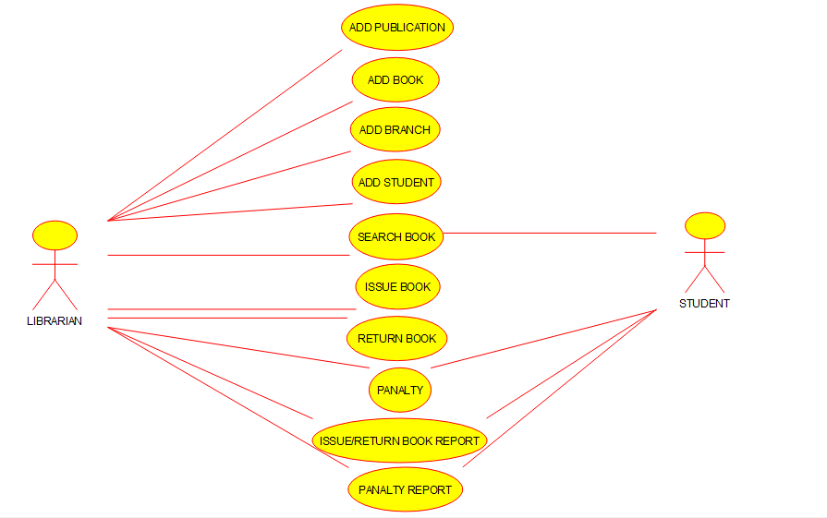

RESULT:

Thus, use case diagram for Library management system is implemented successfully.

Experiment-3

AIM: Draw and validate the flowchart to compute the quotient and remainder.

OBJECTIVE:

**The remainder is the integer left over after dividing one integer by another.** **The quotient is the quantity produced by the division of two numbers**. For example, (7/2) = 3 In the above expression 7 is divided by 2, so the quotient is 3 and the remainder is 1.

PROCEDURE:

* For drawing a flowchart for the above experiment, we have to download Raptor software for PC.
* After downloading the software install it in your PC and open it.
* Your required tools displayed on top left of the screen (execute to completion, pause, stop/reset, step to next shape, test against server, toggle ink and symbols)
* Take reference from google and get flow charts of raptor diagram to draw and validate the flowchart to compute the quotient and remainder.
* Now construct the flowchart accordingly with the help of Raptor tools.
* A RAPTOR program consists of connected symbols that represent actions to be executed.
* The arrows that connect the symbols determine the order in which the actions are performed.
* The execution of a RAPTOR program begins at the Start symbol and goes along the arrows to execute the program.
* The program stops executing when the End symbol is reached.
* After drawing the flowchart diagram save it and take a screen shot of the diagram.
* Go to paint app in your PC and paste the image you captured and select only the image, copy it.
* Now open word document and paste it under related experiment.

OUTPUT:

flowchart to compute the quotient and remainder

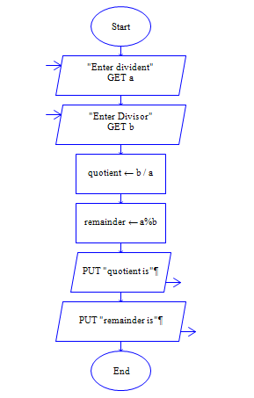

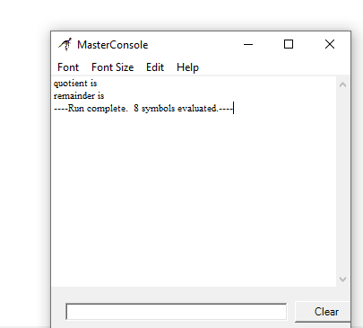

RESULT:

Thus, using Raptor above experiment is implemented successfully.

EXPERIMENT-4

AIM: USE-CASE diagram for Online Shopping system using CASE tools.

OBJECTIVE:

Now a days the life style of the people is different. People feel uncomfortable and time consuming for going crowded markets. So, E-Shopping is a boon as it saves lot of time. Online shopping is a process whereby consumers directly buy goods, services etc. from a seller without an intermediary service over the Internet. Shoppers can visit web stores from the comfort of their house and shop as by sitting in front of the computer. Online stores are usually available 24 hours a day and many consumers have internet access both at work and at home. So, it is very convenient for them to shop Online. One of the most enticing factors about online shopping, particularly during holiday season is, it alleviates the need to wait in long lines or search from a store for a particular item. Variety of goods are available in online. So, the researcher wants to know the preference of the consumers.

PROCEDURE:

* For drawing a use case diagram for online shopping system, we have to download umbrella software for PC.
* After downloading the software install it in your PC and open it.
* Now just above the top of the work space an icon is there which contains several types of diagrams from that select use case.
* Your required tools displayed on top left of the screen (select, note, Anchor, Label, Box, Actor, use case, association, Directional association, Dependency, implements.)
* For drawing use case diagram for online shopping system search a suitable diagram from google for reference. Now go to umbrella software select Actor and place it on the work space and name it as Admin. For this use case diagram, we need another actor and name it as User.
* Now select the use case from tools and name them as Login, add category, add item, manage item, manage order, Registration, View item, make order, Make payment and Change password. (Related to the topic).
* Last step is to draw lines from particular Actors to their related activities.
* After drawing the use case diagram save it and take a screen shot of the diagram.
* Go to paint app in your PC and paste the image you captured and select only the image, copy it.
* Now open word document and paste it under related experiment.

OUTPUT:

USE CASE DIAGRAM FOR ONLINE SHOPPING SYSTEM

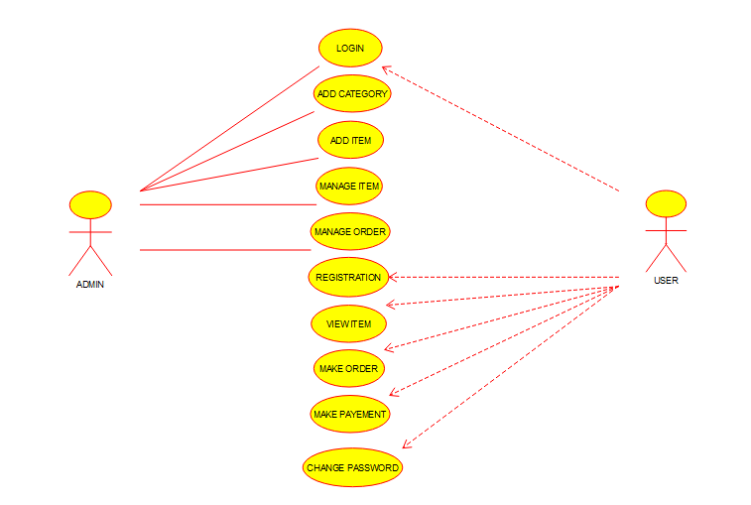

RESULT: Thus, use case diagram for online shopping system is implemented successfully.

EXPERIMENT-5

AIM: USE-CASE diagram for Online Railway Reservation System using CASE tools.

OBJECTIVE:

In Current Railway Ticket Booking System Project User faces various difficulties while booking their tickets by visiting to the reservation counter or by visiting to the agents. Railway Ticket Booking System Project will save customers time and money as well. User will get the facility of making their payments of their choice and get entire information after reservations and many more of the login screen. Finding trains between given routes through simple search query on particular date and displaying all details of that particular train such as arrival time, departure time, number of seats available, class type, charges details and many more. Users will also able to update their profiles and can get details related to their transactions.

Procedure:

* For drawing a use case diagram for online Railway Reservation system, we have to download umbrella software for PC.
* After downloading the software install it in your PC and open it.
* Now just above the top of the work space an icon is there which contains several types of diagrams from that select use case.
* Your required tools displayed on top left of the screen (select, note, Anchor, Label, Box, Actor, use case, association, Directional association, Dependency, implements.)
* For drawing use case diagram for online Railway Reservation system search a suitable diagram from google for reference. Now go to umbrella software select Actor and place it on the work space and name it as Admin. For this use case diagram, we need another actor and name it as Customer.
* Now select the use case from tools and name them as Customer profile, Manage Booking, Book Tickets, manage train info, Search train schedule, manage payment, Make payment, Database Backup and Reports. (Related to the topic).
* Last step is to draw lines from particular Actors to their related activities.
* After drawing the use case diagram save it and take a screen shot of the diagram.
* Go to paint app in your PC and paste the image you captured and select only the image, copy it.
* Now open word document and paste it under related experiment.

Output:

USE CASE DIAGRAM FOR ONLINE RAILWAY RESERVATION SYSTEM

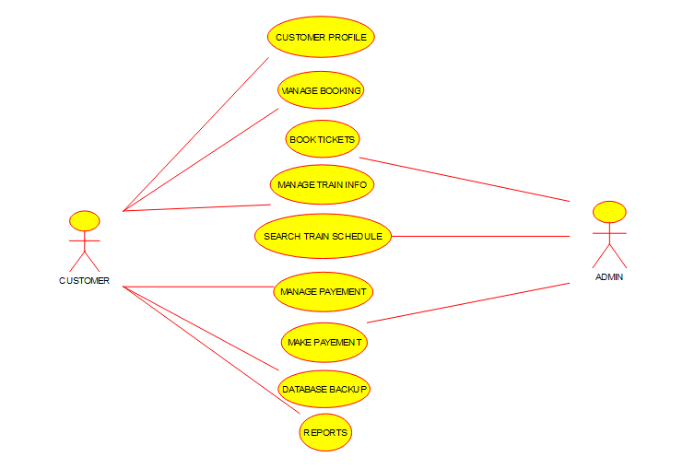

RESULT:

Thus, use case diagram for online Railway reservation system is implemented successfully.

Experiment-6

AIM: USE-CASE diagram for Hospital Management System using CASE tools.

OBJECTIVE:

The objective of the “online hospital management system” is to simply track the knowledge of all the staff, patients, treatment provided, and prescription and also to produce periodic reports for analysis. The main goal of the software is to make a decent management tool. The main purpose of this software is to cut back the time taken through the manual system so as to take care of all the records. This project is helpful to cut back the time and quality of maintaining the records. It also helps the incorrect maintenance of patient and patient details.

PROCEDURE:

* For drawing a use case diagram for Hospital Management system, we have to download umbrella software for PC.
* After downloading the software install it in your PC and open it.
* Now just above the top of the work space an icon is there which contains several types of diagrams from that select use case.
* Your required tools displayed on top left of the screen (select, note, Anchor, Label, Box, Actor, use case, association, Directional association, Dependency, implements.)
* For drawing use case diagram for Hospital management system search a suitable diagram from google for reference. Now go to umbrella software select Actor and place it on the work space and name it as doctor. For this use case diagram, we need another actor and name it as patient.
* Now select the use case from tools and name them as Visit the patient, Examine the patient, add diagnosis, prescribe drugs, Schedule medical procedure, Report the patient condition, Discharge the patient, Register, Unregister, Confirm the medical procedure and apply for discharge. (Related to the topic).
* Last step is to draw lines from particular Actors to their related activities.
* After drawing the use case diagram save it and take a screen shot of the diagram.
* Go to paint app in your PC and paste the image you captured and select only the image, copy it.
* Now open word document and paste it under related experiment.

OUTPUT:

USE CASE DIAGRAM FOR HOSPITAL MANAGEMENT SYSTEM

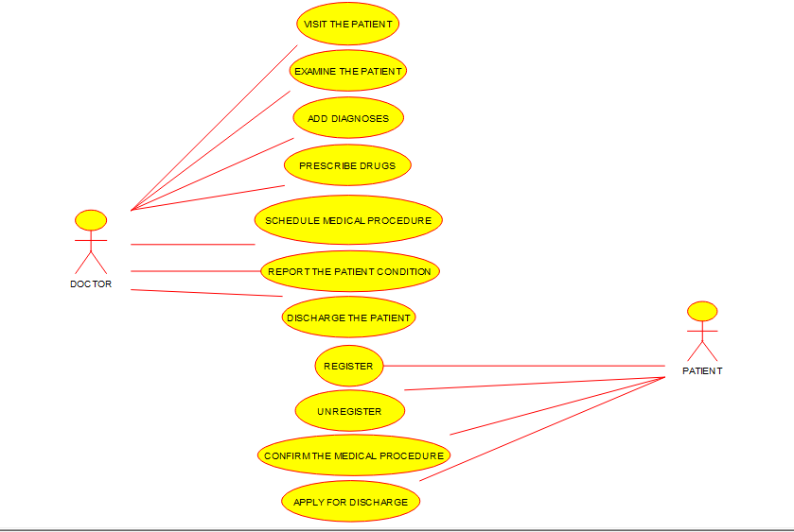

RESULT:

Thus, use case diagram for Hospital management system is implemented successfully.

EXPERIMENT-7

AIM: USE-CASE diagram for ATM system using CASE tools.

OBJECTIVE:

**Automated Teller Machine (ATM)** also known as ABM (Automated Banking Machine) is a banking system. This banking system allows customers or users to have access to financial transactions. These transactions can be done in public space without any need for a clerk, cashier, or bank teller. Working and description of the ATM can be explained with the help of the **Use Case Diagram**.

PROCEDURE:

* For drawing a use case diagram for ATM system, we have to download umbrella software for PC.
* After downloading the software install it in your PC and open it.
* Now just above the top of the work space an icon is there which contains several types of diagrams from that select use case.
* Your required tools displayed on top left of the screen (select, note, Anchor, Label, Box, Actor, use case, association, Directional association, Dependency, implements.)
* For drawing use case diagram for ATM system search a suitable diagram from google for reference. Now go to umbrella software select Actor and place it on the work space and name it as CUSTOMER. For this use case diagram, we need another two actors and name it as TECHNICIAN and BANK.
* Now select the use case from tools and name them as Check balance, Deposit funds, Withdraw cash, transfer funds, Maintenances and Report. (Related to the topic).
* Last step is to draw lines from particular Actors to their related activities.
* After drawing the use case diagram save it and take a screen shot of the diagram.
* Go to paint app in your PC and paste the image you captured and select only the image, copy it.
* Now open word document and paste it under related experiment.

OUTPUT:

USE CASE DIAGRAM FOR ATM SYSTEM

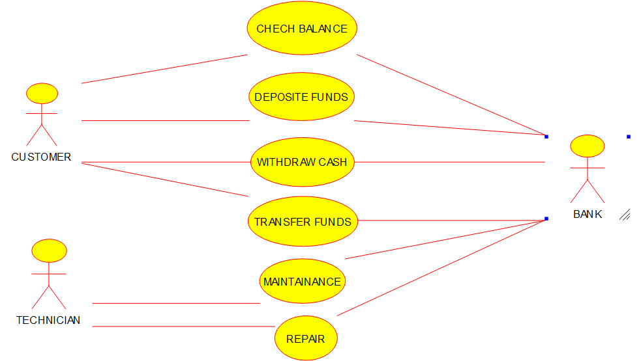

RESULT:

Thus, use case diagram for ATM system is implemented successfully.

EXPERIMENT-8

AIM: USE-CASE diagram for Online college management system using CASE tools.

OBJECTIVE:

Online Intranet College Management System (CMS) that is of importance to either an educational institution or a college. The system (CMS) is an Intranet based application that can be accessed throughout the institution or a specified department. This system may be used for monitoring attendance for the college. Students as well as staffs logging in may also access or can be search any of the information regarding college. Attendance of the staff and students as well as marks of the students will be updated by staff. This system (C.M.S) is being developed for an engineering college to maintain and facilitate easy access to information.

PROCEDURE:

* For drawing a use case diagram for Online college management system, we have to download umbrella software for PC.
* After downloading the software install it in your PC and open it.
* Now just above the top of the work space an icon is there which contains several types of diagrams from that select use case.
* Your required tools displayed on top left of the screen (select, note, Anchor, Label, Box, Actor, use case, association, Directional association, Dependency, implements.)
* For drawing use case diagram for Online college management system search a suitable diagram from google for reference. Now go to umbrella software select Actor and place it on the work space and name it as. For this use case diagram, we need another two actors and name it as TECHNICIAN and BANK.
* Now select the use case from tools and name them as Manage student info, manage student status, manage courses, manage subjects, manage instructor’s info, manage designation and record all transactions. (Related to the topic).
* Last step is to draw lines from particular Actors to their related activities.
* After drawing the use case diagram save it and take a screen shot of the diagram.
* Go to paint app in your PC and paste the image you captured and select only the image, copy it.
* Now open word document and paste it under related experiment.

OUTPUT:

USE-CASE DIAGRAM FOR ONLINE COLLEGE MANAGEMENT SYSTEM

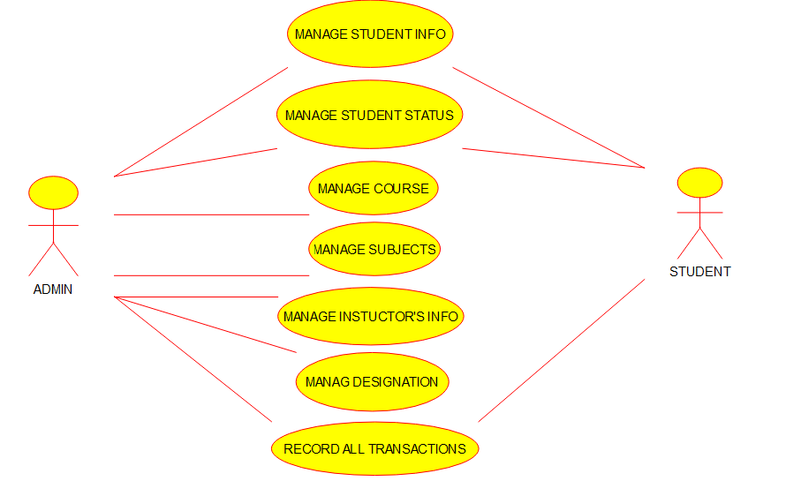

RESULT:

Thus, use case diagram for Online college management system is implemented successfully.

Experiment-9

AIM: USE-CASE diagram for Online Airline Reservation system using CASE tools.

OBJECTIVE:

Airline computerized reservation systems (CRS) are the primary form of travel agency computerization in the world. These systems manage the millions of reservation requests and cancellations, fare, and reservation pricing requests that are initiated by travel agencies using these systems—not to mention the thousands of database changes that occur daily. The CRS function as extremely powerful and valuable distribution and marketing tools for their airline owners.

PROCEDURE:

* For drawing a use case diagram for Online Airline reservation system, we have to download umbrella software for PC.
* After downloading the software install it in your PC and open it.
* Now just above the top of the work space an icon is there which contains several types of diagrams from that select use case.
* Your required tools displayed on top left of the screen (select, note, Anchor, Label, Box, Actor, use case, association, Directional association, Dependency, implements.)
* For drawing use case diagram for Online Airline reservation system search a suitable diagram from google for reference. Now go to umbrella software select Actor and place it on the work space and name it as Passenger. For this use case diagram, we need another two actors and name it as Bank payment portal and Airline server.
* Now select the use case from tools and name them as Login, Check availability, book tickets, fill details, make payment, generate ticket. (Related to the topic).
* Last step is to draw lines from particular Actors to their related activities.
* After drawing the use case diagram save it and take a screen shot of the diagram.
* Go to paint app in your PC and paste the image you captured and select only the image, copy it.
* Now open word document and paste it under related experiment.

OUTPUT:

USE-CASE DIAGRAM FOR ONLINE AIRLINE RESERVTION SYSTEM

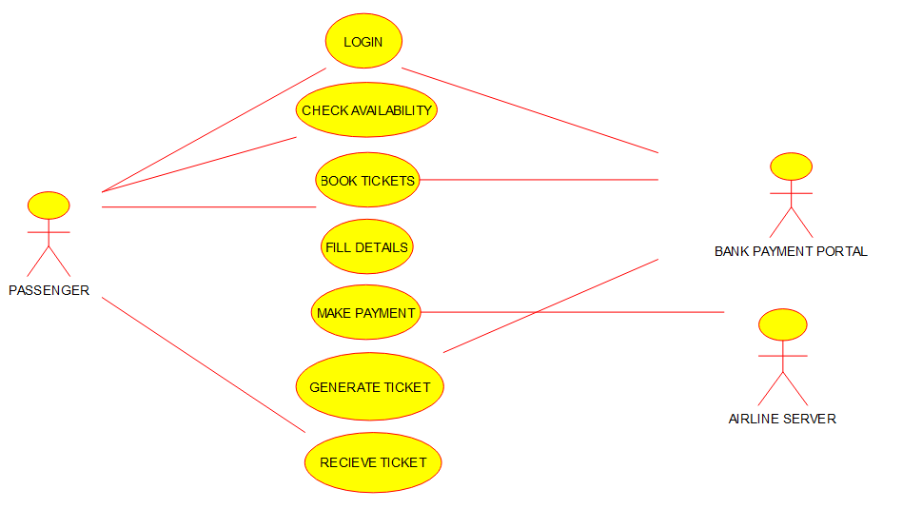

RESULT:

Thus, use case diagram for Online Airline reservation system is implemented successfully.

Experiment-10

AIM: Class diagram for online Airline Reservation system using CASE tools.

OBJECTIVE:

Airline computerized reservation systems (CRS) are the primary form of travel agency computerization in the world. These systems manage the millions of reservation requests and cancellations, fare, and reservation pricing requests that are initiated by travel agencies using these systems—not to mention the thousands of database changes that occur daily. The CRS function as extremely powerful and valuable distribution and marketing tools for their airline owners.

PROCEDURE:

* For drawing a class diagram for Online Airline reservation system, we have to download umbrella software for PC.
* After downloading the software install it in your PC and open it.
* Now just above the top of the work space an icon is there which contains several types of diagrams from that select class diagram.
* Your required tools displayed on top left of the screen (select, note, Anchor, Label, box, class, interface, datatype, Enum, package, association, Directional association, Dependency, implements, composition, aggregation and containment.)
* For drawing use case diagram for Online Airline reservation system search a suitable diagram from google for reference and draw the diagram in the work space as shown in google with the help of tools.
* After drawing the class diagram save it and take a screen shot of the diagram.
* Go to paint app in your PC and paste the image you captured and select only the image, copy it.
* Now open word document and paste it under related experiment.

OUTPUT:

CLASS DIAGRAM FOR ONLINE AIRLINE RESERVATION SYSTEM

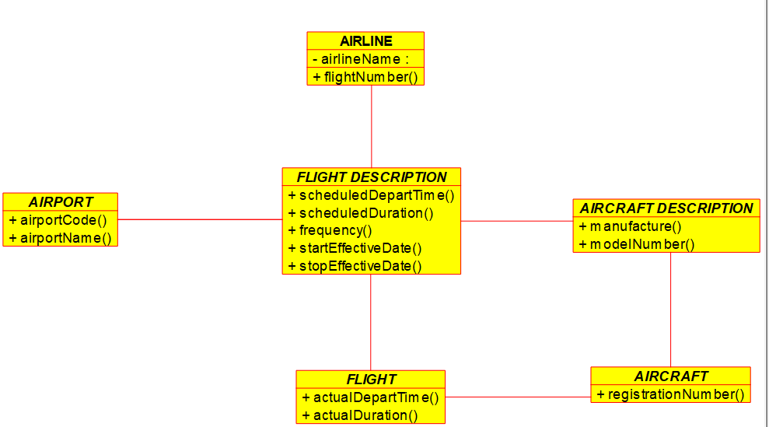

RESULT:

Thus, class diagram for Online Airline reservation system is implemented successfully.

Experiment-11

AIM: Class diagram for Online Voting System using CASE tools.

OBJECTIVE:

As an alternative for easy voting system, where rigging of votes, insecurity etc. are usual which can be eliminated. At the same time, this new voting system is electoral voting System is easy to use, both for the official and people concerned. This type of voting system can completely eradicate all kinds of fraudulent activities especially casting votes from Same id more than once We are implementing the electronic voting system with the help of python.

PROCEDURE:

* For drawing a class diagram for Online voting system, we have to download umbrella software for PC.
* After downloading the software install it in your PC and open it.
* Now just above the top of the work space an icon is there which contains several types of diagrams from that select class diagram.
* Your required tools displayed on top left of the screen (select, note, Anchor, Label, box, class, interface, datatype, Enum, package, association, Directional association, Dependency, implements, composition, aggregation and containment.)
* For drawing use case diagram for Online voting system search a suitable diagram from google for reference and draw the diagram in the work space as shown in google with the help of tools.
* After drawing the class diagram save it and take a screen shot of the diagram.
* Go to paint app in your PC and paste the image you captured and select only the image, copy it.
* Now open word document and paste it under related experiment.

OUTPUT:

CLASS DIAGRAM FOR ONLINE VOTING SYSTEM

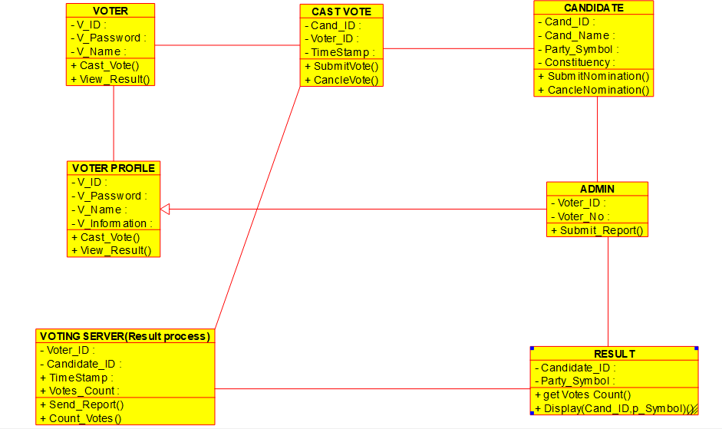

RESULT:

Thus, class diagram for Online voting system is implemented successfully.

EXPERIMENT-12

AIM: Class diagram for Library management System using CASE tools.

OBJECTIVE:

With the advancement of technology, it is imperative to exalt all the systems into a user-friendly manner. The Library Management system (LMS) acts as a tool to transform traditional libraries into digital libraries. In traditional libraries, the students/user has to search for books which are hassle process and there is no proper maintenance of database about issues/fines. The overall progress of work is slow and it is impossible to generate a fast report. The librarians have to work allotted for arranging, sorting books in the book sells. At the same time, they have to check and monitor the lend/borrow book details with its fine. It is a tedious process to work simultaneously in different sectors.

PROCEDURE:

* For drawing a class diagram for Library management system, we have to download umbrella software for PC.
* After downloading the software install it in your PC and open it.
* Now just above the top of the work space an icon is there which contains several types of diagrams from that select class diagram.
* Your required tools displayed on top left of the screen (select, note, Anchor, Label, box, class, interface, datatype, Enum, package, association, Directional association, Dependency, implements, composition, aggregation and containment.)
* For drawing use case diagram for Library management system search a suitable diagram from google for reference and draw the diagram in the work space as shown in google with the help of tools.
* After drawing the class diagram save it and take a screen shot of the diagram.
* Go to paint app in your PC and paste the image you captured and select only the image, copy it.
* Now open word document and paste it under related experiment.

OUTPUT:

CLASS DIAGRAM FOR LIBRARY MANAGEMENT SYSTEM.

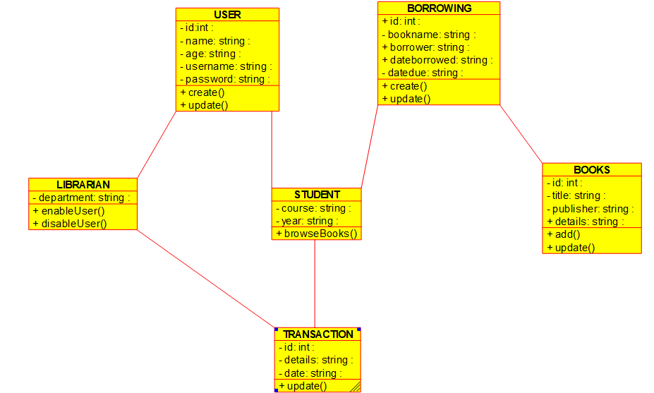

RESULT:

Thus, class diagram for Library management system is implemented successfully.

EXPERIMENT-13

AIM: Class diagram for Online shopping System using CASE tools.

OBJECTIVE:

Now a days the life style of the people is different. People feel uncomfortable and time consuming for going crowded markets. So, E-Shopping is a boon as it saves lot of time. Online shopping is a process whereby consumers directly buy goods, services etc. from a seller without an intermediary service over the Internet. Shoppers can visit web stores from the comfort of their house and shop as by sitting in front of the computer. Online stores are usually available 24 hours a day and many consumers have internet access both at work and at home. So, it is very convenient for them to shop Online.

PROCEDURE:

* For drawing a class diagram for online shopping system, we have to download umbrella software for PC.
* After downloading the software install it in your PC and open it.
* Now just above the top of the work space an icon is there which contains several types of diagrams from that select class diagram.
* Your required tools displayed on top left of the screen (select, note, Anchor, Label, box, class, interface, datatype, Enum, package, association, Directional association, Dependency, implements, composition, aggregation and containment.)
* For drawing use case diagram for online shopping system search a suitable diagram from google for reference and draw the diagram in the work space as shown in google with the help of tools.
* After drawing the class diagram save it and take a screen shot of the diagram.
* Go to paint app in your PC and paste the image you captured and select only the image, copy it.
* Now open word document and paste it under related experiment.

OUTPUT:

CLASS DIAGRAM FOR ONLINE SHOPPING SYSTEM.

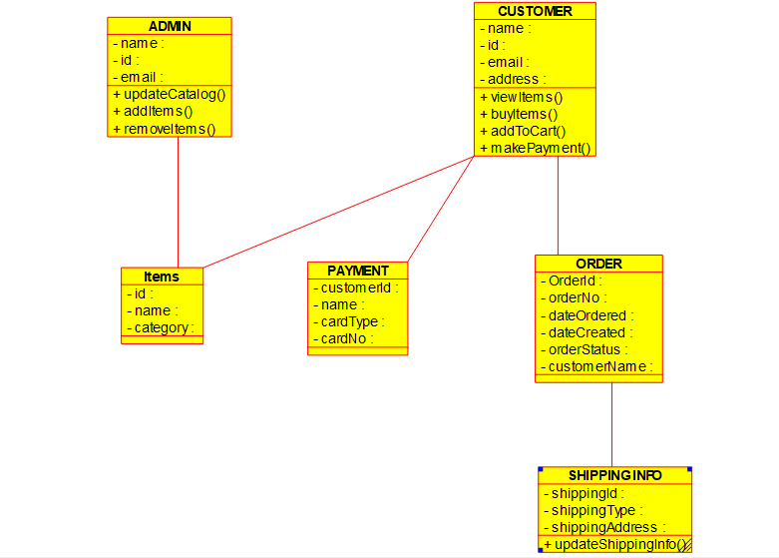

RESULT:

Thus, class diagram for Online Shopping system is implemented successfully.

EXPERIMENT-14

AIM: Class diagram for Online Railway reservation System using CASE tools.

OBJECTIVE:

In Current Railway Ticket Booking System Project User faces various difficulties while booking their tickets by visiting to the reservation counter or by visiting to the agents. Railway Ticket Booking System Project will save customers time and money as well. User will get the facility of making their payments of their choice and get entire information after reservations and many more of the login screen. Finding trains between given routes through simple search query on particular date and displaying all details of that particular train such as arrival time, departure time, number of seats available, class type, charges details and many more. Users will also able to update their profiles and can get details related to their transactions.

PROCEDURE:

* For drawing a class diagram for online Railway reservation system, we have to download umbrella software for PC.
* After downloading the software install it in your PC and open it.
* Now just above the top of the work space an icon is there which contains several types of diagrams from that select class diagram.
* Your required tools displayed on top left of the screen (select, note, Anchor, Label, box, class, interface, datatype, Enum, package, association, Directional association, Dependency, implements, composition, aggregation and containment.)
* For drawing use case diagram for online Railway reservation system search a suitable diagram from google for reference and draw the diagram in the work space as shown in google with the help of tools.
* After drawing the class diagram save it and take a screen shot of the diagram.
* Go to paint app in your PC and paste the image you captured and select only the image, copy it.
* Now open word document and paste it under related experiment.

OUTPUT:

CLASS DIAGRAM FOR ONLINE RAILWAY RESERVATION SYSTEM.

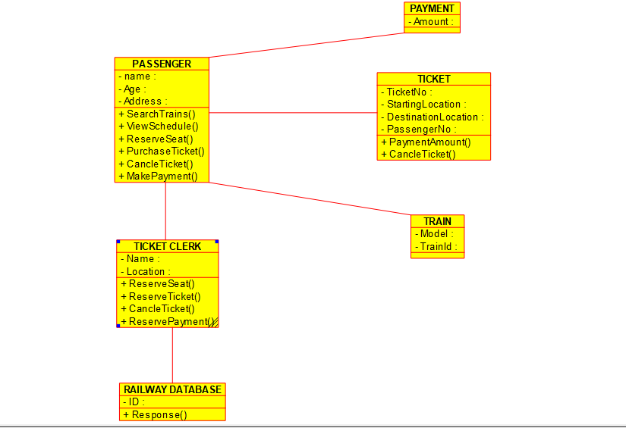

RESULT:

Thus, class diagram for Online Railway reservation system is implemented successfully.

EXPERIMENT-15

AIM: Activity diagram for online Voting system using CASE tools.

OBJECTIVE:

As an alternative for is easy voting system, where rigging of votes, insecurity etc. are usual which can be eliminated. At the same time, this new voting system is electoral voting System is easy to use, both for the official and people concerned. This type of voting system can completely eradicate all kinds of fraudulent activities especially casting votes from Same id more than once We are implementing the electronic voting system with the help of python.

PROCEDURE:

* For drawing an activity diagram for online Voting system, we have to download umbrella software for PC.
* After downloading the software install it in your PC and open it.
* Now just above the top of the work space an icon is there which contains several types of diagrams from that select Activity diagram.
* Your required tools displayed on top left of the screen (select, note, anchor, label, box, initial activity, activity, end activity, final activity, branch/merge, fork/join, activity transition, exception, pre/post condition, send signal, accept signal, accept time event, region, pin and object node).
* For drawing activity diagram for online voting system search a suitable diagram from google for reference and draw the diagram in the work space as shown in google with the help of tools.
* After drawing the activity diagram save it and take a screen shot of the diagram.
* Go to paint app in your PC and paste the image you captured and select only the image, copy it.
* Now open word document and paste it under related experiment.

OUTPUT:

ACTIVITY DIAGRAM FOR ONLINE VOTING SYSTEM.

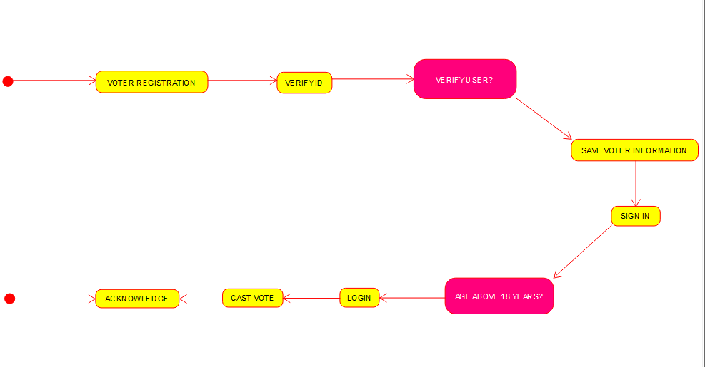

RESULT:

Thus, Activity diagram for Online voting system is implemented successfully.

EXPERIMENT-16

AIM: Activity diagram for Library management system using CASE tools.

OBJECTIVE:

With the advancement of technology, it is imperative to exalt all the systems into a user-friendly manner. The Library Management system (LMS) acts as a tool to transform traditional libraries into digital libraries. In traditional libraries, the students/user has to search for books which are hassle process and there is no proper maintenance of database about issues/fines. The overall progress of work is slow and it is impossible to generate a fast report. The librarians have to work allotted for arranging, sorting books in the book sells. At the same time, they have to check and monitor the lend/borrow book details with its fine. It is a tedious process to work simultaneously in different sectors.

POCEDURE:

* For drawing an activity diagram for online library management system, we have to download umbrella software for PC.
* After downloading the software install it in your PC and open it.
* Now just above the top of the work space an icon is there which contains several types of diagrams from that select Activity diagram.
* Your required tools displayed on top left of the screen (select, note, anchor, label, box, initial activity, activity, end activity, final activity, branch/merge, fork/join, activity transition, exception, pre/post condition, send signal, accept signal, accept time event, region, pin and object node).
* For drawing activity diagram for library management system search a suitable diagram from google for reference and draw the diagram in the work space as shown in google with the help of tools.
* After drawing the activity diagram save it and take a screen shot of the diagram.
* Go to paint app in your PC and paste the image you captured and select only the image, copy it.
* Now open word document and paste it under related experiment.

OUTPUT:

ACTIVITY DIAGRAM FOR LIBRARY MANAGEMENT SYSTEM.

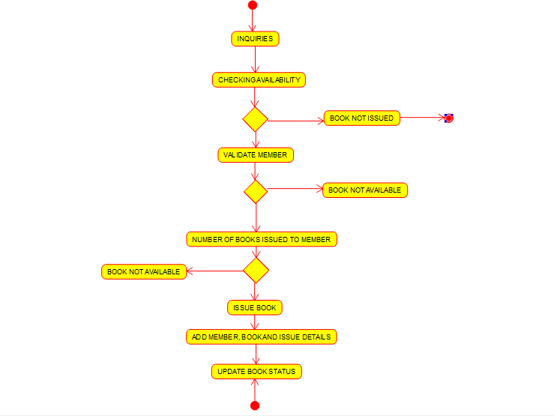

RESULT:

Thus, Activity diagram for Library management system is implemented successfully.

EXPERIMENT-17

AIM: Activity diagram for Online shopping system using CASE tools.

OBJECTIVE:

Now a days the life style of the people is different. People feel uncomfortable and time consuming for going crowded markets. So, E-Shopping is a boon as it saves lot of time. Online shopping is a process whereby consumers directly buy goods, services etc. from a seller without an intermediary service over the Internet. Shoppers can visit web stores from the comfort of their house and shop as by sitting in front of the computer. Online stores are usually available 24 hours a day and many consumers have internet access both at work and at home. So, it is very convenient for them to shop Online. One of the most enticing factors about online shopping, particularly during holiday season is, it alleviates the need to wait in long lines or search from a store for a particular item. Variety of goods are available in online. So, the researcher wants to know the preference of the consumers.

PROCEDURE:

* For drawing an activity diagram for online shopping system, we have to download umbrella software for PC.
* After downloading the software install it in your PC and open it.
* Now just above the top of the work space an icon is there which contains several types of diagrams from that select Activity diagram.
* Your required tools displayed on top left of the screen (select, note, anchor, label, box, initial activity, activity, end activity, final activity, branch/merge, fork/join, activity transition, exception, pre/post condition, send signal, accept signal, accept time event, region, pin and object node).
* For drawing activity diagram for online shopping system search a suitable diagram from google for reference and draw the diagram in the work space as shown in google with the help of tools.
* After drawing the activity diagram save it and take a screen shot of the diagram.
* Go to paint app in your PC and paste the image you captured and select only the image, copy it.
* Now open word document and paste it under related experiment.

OUTPUT:

ACTIVITY DIAGRAM FOR ONLINE SHOPPING SYSTEM.

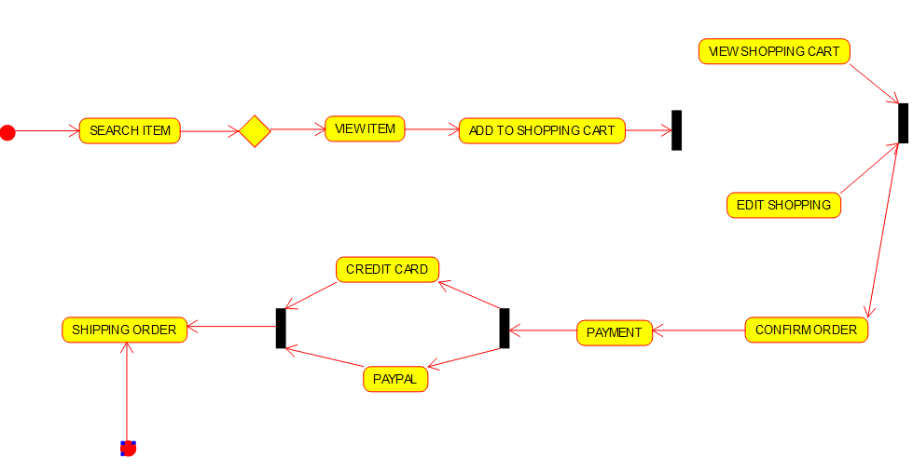

RESULT:

Thus, Activity diagram for Online shopping system is implemented successfully.

EXPERIMENT-18

AIM: Activity diagram for Online Railway reservation system using CASE tools.

OBJECTIVE:

In Current Railway Ticket Booking System Project User faces various difficulties while booking their tickets by visiting to the reservation counter or by visiting to the agents. Railway Ticket Booking System Project will save customers time and money as well. User will get the facility of making their payments of their choice and get entire information after reservations and many more of the login screen. Finding trains between given routes through simple search query on particular date and displaying all details of that particular train such as arrival time, departure time, number of seats available, class type, charges details and many more. Users will also able to update their profiles and can get details related to their transactions.

PROCEDURE:

* For drawing an activity diagram for online railway reservation system, we have to download umbrella software for PC.
* After downloading the software install it in your PC and open it.
* Now just above the top of the work space an icon is there which contains several types of diagrams from that select Activity diagram.
* Your required tools displayed on top left of the screen (select, note, anchor, label, box, initial activity, activity, end activity, final activity, branch/merge, fork/join, activity transition, exception, pre/post condition, send signal, accept signal, accept time event, region, pin and object node).
* For drawing activity diagram for online railway reservation system search a suitable diagram from google for reference and draw the diagram in the work space as shown in google with the help of tools.
* After drawing the activity diagram save it and take a screen shot of the diagram.
* Go to paint app in your PC and paste the image you captured and select only the image, copy it.
* Now open word document and paste it under related experiment.

OUTPUT:

ACTIVITY DIAGRAM FOR ONLINE RAILWAY RESERVATION SYSTEM.

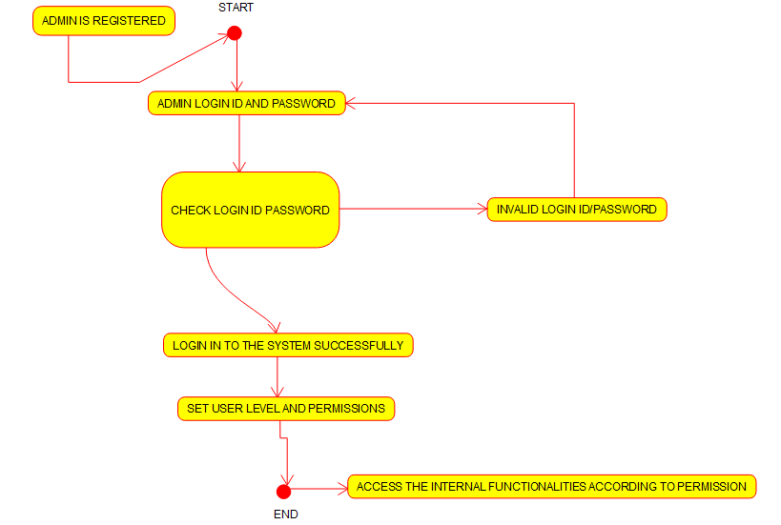

RESULT:

Thus, Activity diagram for Online Railway reservation system is implemented successfully.

EXPERIMENT-19

AIM: Activity diagram for Hospital management system using CASE tools.

OBJECTIVE:

The objective of the “online hospital management system” is to simply track the knowledge of all the staff, patients, treatment provided, and prescription and also to produce periodic reports for analysis. The main goal of the software is to make a decent management tool. The main purpose of this software is to cut back the time taken through the manual system so as to take care of all the records. This project is helpful to cut back the time and quality of maintaining the records. It also helps the incorrect maintenance of patient and patient details.

PROCEDURE:

* For drawing an Activity diagram for Hospital management system, we have to download umbrella software for PC.
* After downloading the software install it in your PC and open it.
* Now just above the top of the work space an icon is there which contains several types of diagrams from that select Activity diagram.
* Your required tools displayed on top left of the screen (select, note, anchor, label, box, initial activity, activity, end activity, final activity, branch/merge, fork/join, activity transition, exception, pre/post condition, send signal, accept signal, accept time event, region, pin and object node).
* For drawing activity diagram for Hospital management system search a suitable diagram from google for reference and draw the diagram in the work space as shown in google with the help of tools.
* After drawing the activity diagram save it and take a screen shot of the diagram.
* Go to paint app in your PC and paste the image you captured and select only the image, copy it.
* Now open word document and paste it under related experiment.

OUTPUT:

ACTIVITY DIAGRAM FOR HOSPITAL MANAGEMENT SYSTEM.

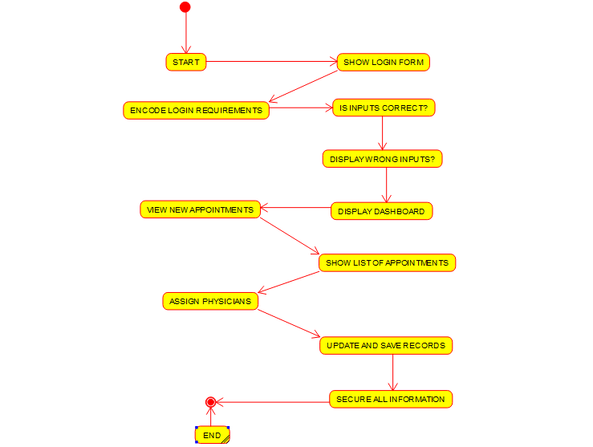

RESULT:

Thus, Activity diagram for Hospital management system is implemented successfully.

EXPERIMENT-20

AIM: Using Raptor drawing the flowchart to check whether the given number is a palindrome or not.

OBJECTIVE:

The logic of a palindrome is simple, wherein **if we take a number and reverse it, it still stays the same as the original number**. For example, 10101 is a palindrome number as it is going to stay the same even if we reverse it. An integer is a palindrome if the reverse of that number is equal to the original number.

PROCEDURE:

* For drawing a flowchart to check whether the given number is a palindrome or not, we have to download Raptor software for PC.
* After downloading the software install it in your PC and open it.
* Your required tools displayed on top left of the screen (execute to completion, pause, stop/reset, step to next shape, test against server, toggle ink and symbols)
* Take reference from google and get flow charts of raptor diagram to check whether the given number is a palindrome or not.
* Now construct the flowchart accordingly with the help of Raptor tools.
* A RAPTOR program consists of connected symbols that represent actions to be executed.
* The arrows that connect the symbols determine the order in which the actions are performed.
* The execution of a RAPTOR program begins at the Start symbol and goes along the arrows to execute the program.
* The program stops executing when the End symbol is reached.
* After drawing the flowchart diagram save it and take a screen shot of the diagram.
* Go to paint app in your PC and paste the image you captured and select only the image, copy it.
* Now open word document and paste it under related experiment.

OUTPUT:

FLOWCHART TO CHECK WHEATHER A GIVEN NUMBER IS POLINDROME OR NOT USING RAPTOR.

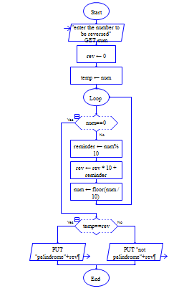

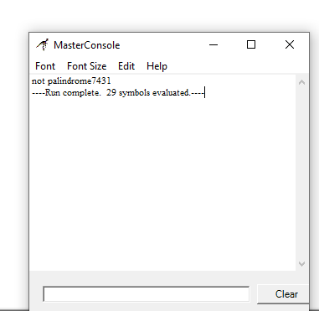

RESULT:

Thus, using Raptor above experiment is implemented successfully.

EXPERIMENT-21

AIM: Using Raptor drawing the flowchart to calculate Fibonacci series.

OBJECTIVE:

A Fibonacci number is a series of numbers in which each Fibonacci number is obtained by adding the two preceding numbers. It means that the next number in the series is the addition of two previous numbers. Let the first two numbers in the series be taken as 0 and 1. By adding 0 and 1, we get the third number as 1. Then by adding the second and the third number (i.e.) 1 and 1, we get the fourth number as 2, and similarly, the process goes on. Thus, we get the Fibonacci series as 0, 1, 1, 2, 3, 5, 8, ……. Hence, the obtained series is called the Fibonacci number series.

PROCEDURE:

* For drawing a flowchart to calculate Fibonacci series, we have to download Raptor software for PC.
* After downloading the software install it in your PC and open it.
* Your required tools displayed on top left of the screen (execute to completion, pause, stop/reset, step to next shape, test against server, toggle ink and symbols)
* Take reference from google and get flow charts to calculate Fibonacci series.
* Now construct the flowchart accordingly with the help of Raptor tools.
* A RAPTOR program consists of connected symbols that represent actions to be executed.
* The arrows that connect the symbols determine the order in which the actions are performed.
* The execution of a RAPTOR program begins at the Start symbol and goes along the arrows to execute the program.
* The program stops executing when the End symbol is reached.
* After drawing the flowchart diagram save it and take a screen shot of the diagram.
* Go to paint app in your PC and paste the image you captured and select only the image, copy it.
* Now open word document and paste it under related experiment

OUTPUT:

FLOWCHART TO CALCULATE FIBONACCI SERIES USING RAPTOR.

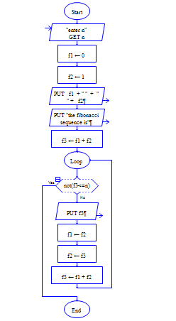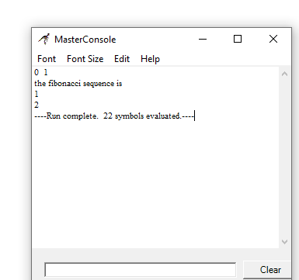

RESULT:

Thus, using Raptor above experiment is implemented successfully.

EXPERIMENT-22

AIM: Using Raptor drawing the flowchart to swap two characters.

OBJECTIVE:

Swapping refers to **the exchange of two or more things**. For example, in programming data may be swapped between two variables, or things may be swapped between two people. Swapping may specifically refer to: In computer systems, an older form of memory management, similar to paging. Swapping (barter)

PROCEDURE:

* For drawing a flowchart to swap two numbers, we have to download Raptor software for PC.
* After downloading the software install it in your PC and open it.
* Your required tools displayed on top left of the screen (execute to completion, pause, stop/reset, step to next shape, test against server, toggle ink and symbols)
* Take reference from google and get flow charts to swap two number.
* Now construct the flowchart accordingly with the help of Raptor tools.
* A RAPTOR program consists of connected symbols that represent actions to be executed.
* The arrows that connect the symbols determine the order in which the actions are performed.
* The execution of a RAPTOR program begins at the Start symbol and goes along the arrows to execute the program.
* The program stops executing when the End symbol is reached.
* After drawing the flowchart diagram save it and take a screen shot of the diagram.
* Go to paint app in your PC and paste the image you captured and select only the image, copy it.
* Now open word document and paste it under related experiment.

OUTPUT:

FLOWCHART TO SWAP TWO CHARACTERS USING RAPTOR.

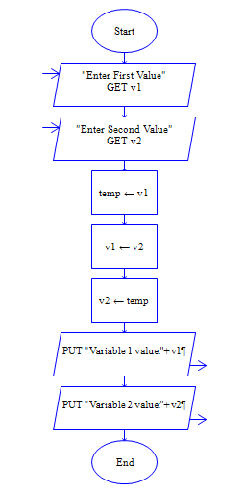

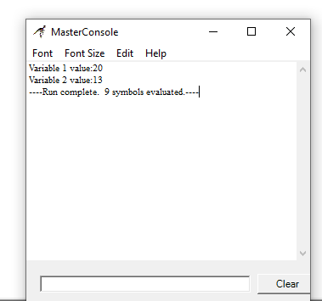

RESULT:

Thus, using Raptor above experiment is implemented successfully.

EXPERIMENT-23

AIM: Using Raptor drawing the flowchart to display the length of the string.

OBJECTIVE:

The length or size of a string means **the total number of characters present in it**. For Example: The string “Geeks for Geeks” has 15 characters Declare a variable of type String. Initialize the String variable to a non-null value. Hold the value of the String length in a variable for future use.

PROCEDURE:

* For drawing a flowchart to display the length of the string, we have to download Raptor software for PC.
* After downloading the software install it in your PC and open it.
* Your required tools displayed on top left of the screen (execute to completion, pause, stop/reset, step to next shape, test against server, toggle ink and symbols)
* Take reference from google and get flow charts of raptor diagram to display the length of the string.
* Now construct the flowchart accordingly with the help of Raptor tools.
* A RAPTOR program consists of connected symbols that represent actions to be executed.
* The arrows that connect the symbols determine the order in which the actions are performed.
* The execution of a RAPTOR program begins at the Start symbol and goes along the arrows to execute the program.
* The program stops executing when the End symbol is reached.
* After drawing the flowchart diagram save it and take a screen shot of the diagram.
* Go to paint app in your PC and paste the image you captured and select only the image, copy it.
* Now open word document and paste it under related experiment.

.

OUTPUT:

FLOWCHART TO DISPLAY THE LENGTH OF THE STRING USING RAPTOR.

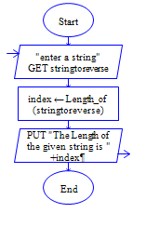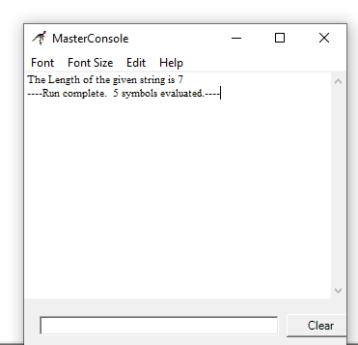

RESULT:

Thus, using Raptor above experiment is implemented successfully.

EXPERIMENT-24

AIM: Using Raptor drawing the flowchart to find whether the given number is prime or not.

OBJECTIVE: A prime number is a whole number greater than 1 whose only factors are 1 and itself. A factor is a whole number that can be divided evenly into another number. The first few prime numbers are 2, 3, 5, 7, 11, 13, 17, 19, 23 and 29. Every prime number can be written in the form of **6n + 1 or 6n – 1** (except the multiples of prime numbers, i.e., 2, 3, 5, 7, 11), where n is a natural number. **If a number has only two factors 1 and itself, then the number is prime**. Hence, by prime factorization of the given number, we can easily determine a prime number.

PROCEDURE:

* For drawing a flowchart to find whether the given number is prime or not, we have to download Raptor software for PC.
* After downloading the software install it in your PC and open it.
* Your required tools displayed on top left of the screen (execute to completion, pause, stop/reset, step to next shape, test against server, toggle ink and symbols)
* Take reference from google and get flow charts of raptor diagram to find whether the given number is prime or not.
* Now construct the flowchart accordingly with the help of Raptor tools.
* A RAPTOR program consists of connected symbols that represent actions to be executed.
* The arrows that connect the symbols determine the order in which the actions are performed.
* The execution of a RAPTOR program begins at the Start symbol and goes along the arrows to execute the program.
* The program stops executing when the End symbol is reached.
* After drawing the flowchart diagram save it and take a screen shot of the diagram.
* Go to paint app in your PC and paste the image you captured and select only the image, copy it.
* Now open word document and paste it under related experiment.

OUTPUT:

FLOWCHART TO FIND WHETHER THE GIVEN NUMBER IS PRIME OR NOT USING RAPTOR.

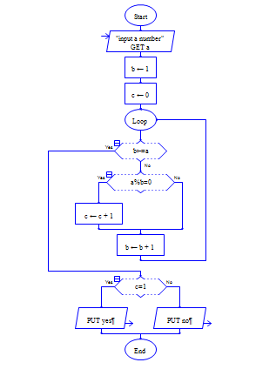

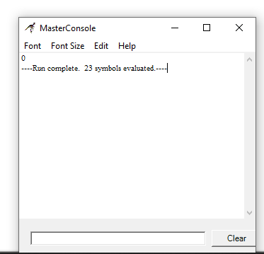

RESULT: Thus, using Raptor above experiment is implemented successfully.

EXPERIMENT-25

AIM: Finding Cyclomatic Complexity for a graph having number of edges as 12, number of nodes as 13 and number of predicate nodes in the flow graph as 5.

OBJECTIVE:

The Cyclomatic complexity defines the number of independent paths in the basis set of the program that provides the upper bound for the number of tests that must be conducted to ensure that all the statements have been executed at least once.

PROCEDURE:

* For drawing a flowchart for the above experiment, we have to download Raptor software for PC.
* After downloading the software install it in your PC and open it.
* Your required tools displayed on top left of the screen (execute to completion, pause, stop/reset, step to next shape, test against server, toggle ink and symbols)
* Take reference from google and get flow charts of raptor diagram Find Cyclomatic Complexity for a graph having number of edges as 12, number of nodes as 13 and number of predicate nodes in the flow graph as 5.
* Now construct the flowchart accordingly with the help of Raptor tools.
* A RAPTOR program consists of connected symbols that represent actions to be executed.
* The arrows that connect the symbols determine the order in which the actions are performed.
* The execution of a RAPTOR program begins at the Start symbol and goes along the arrows to execute the program.
* The program stops executing when the End symbol is reached.
* After drawing the flowchart diagram save it and take a screen shot of the diagram.
* Go to paint app in your PC and paste the image you captured and select only the image, copy it.
* Now open word document and paste it under related experiment.

OUTPUT:

Finding Cyclomatic Complexity for a graph having number of edges as 12, number of nodes as 13 and number of predicate nodes in the flow graph as 5.

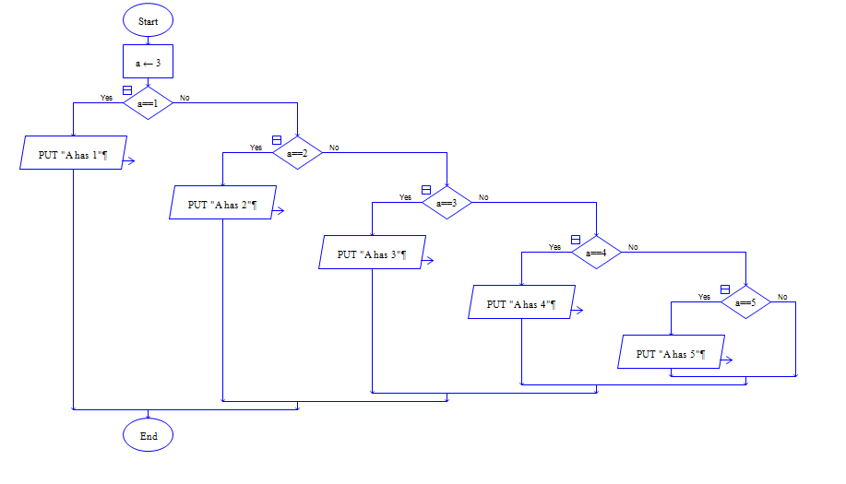

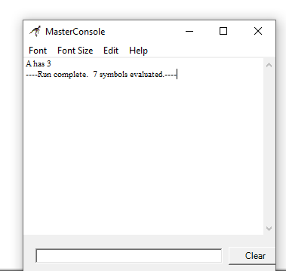

RESULT:

Thus, using Raptor above experiment is implemented successfully.